**Chapter 163**

**ZONING**

**ARTICLE I**

**General Provisions**

**§ 163-1. Title.**

**§ 163-2. Purpose.**

**§ 163-3. Establishment of districts.**

**§ 163-4. Interpretation of zone boundaries.**

**§ 163-5. Annexation.**

**§ 163-6. Overall community objectives.**

**§ 163-7. Language interpretation; definitions.**

**ARTICLE II**

**R-1 One-Family Residence District**

**§ 163-8. Permitted uses.**

**§ 163-9. Conditional uses.**

**§ 163-10. Special exceptions.**

**§ 163-11. Bulk regulations.**

**ARTICLE III**

**R-2 Two Family Residence District**

**§ 163-12. Permitted uses.**

**§ 163-13. Conditional uses.**

**§ 163.14. Special exceptions.**

**§ 163-15. Bulk regulations.**

**ARTICLE IV**

**R-3 Residence District**

**§ 163-16. Permitted uses.**

**§ 163-17. Conditional uses.**

**§ 163-18. Bulk regulations.**

**ARTICLE V**

**C-1 Convenience Commercial District**

**§ 163-19. Permitted uses.**

**§ 163-20. Conditional uses.**

**§ 163-21. Special exceptions.**

**§ 163-22. Bulk regulations.**

**ARTICLE VI**

**C-2 General Commercial District**

**§ 163-23. Permitted uses.**

**§ 163-24. Special exceptions.**

**§ 163-25. Bulk regulations**.

**ARTICLE VII**

**M General Industrial District**

**§ 163-26. Permitted uses.**

**§ 163-27. Conditional uses.**

**§ 163-28. Special exceptions.**

**§ 163-29. Bulk regulations.**

**ARTICLE VIII**

**Supplemental Regulations**

**§ 163-30. General use provisions and exceptions.**

**§ 163-31. Parking requirements.**

**§ 163-32. Home occupations.**

**§ 163-33. Nonconforming uses.**

**§ 163-34. Clear sight triangle**.

**ARTICLE IX**

**Signs and Lights**

**§ 163-35. R Districts.**

**§ 163-36. C Districts.**

**§ 163-37. M Districts.**

**§ 163-38. General sign and light provisions**.

**ARTICLE X**

**Zoning Officer**

**§ 163-39. Administration and enforcement.**

**§163-40. Permits**.

**ARTICLE XI**

**Zoning Hearing Board**

**§ 163-41. Administration and enforcement.**

**§ 163-42. Administrative review.**

**§ 163-43. Special Exceptions.**

**§ 163-44. Variances.**

**§ 163-45. Reversing decisions of Zoning Officer.**

**§ 163-46. Mediation option.**

**§ 163-47. Intent.**

**§ 163-48. Fees and amendments.**

**§ 163-49. Amendments to Zoning Ordinance.**

**ARTICLE XII**

**Planning Commission**

**§ 163-50. Planning Commission.**

**§ 163-51. Powers and duties of Planning Commission.**

**§ 163-52. Membership.**

**§ 163-53. Removal.**

**§ 163-54. Appointment, term and vacancy.**

**§ 163-55. Conduct of business.**

**§ 163-56. Administrative and technical assistance.**

**§ 163-57. Assistance.**

**Use Regulations Summary Table**

**Bulk Regulations Summary Table**

**Zoning Map**

**ARTICLE XIII**

**Sexually Oriented Establishments**

**§ 163-58. Intent.**

**§ 163-59. Definitions.**

**§ 163-60. Classification.**

**§ 163-61. Permit required; application; inspection.**

**§ 163-62. Issuance of permit.**

**§ 163-63. Fees.**

**§ 163-64. Inspection.**

**§ 163-65. Expiration of permit.**

**§ 163-66. Suspension of permit.**

**§ 163-67. Revocation of permit.**

**§ 163-68. Transfer of permit.**

**§ 163-69. Location of sexually oriented businesses.**

**§ 163-70. Exemptions.**

**§ 163-71. Injunction.**

**§ 163-72. Severability.**

**[HISTORY: Adopted by the Borough Council of the Borough of South Greensburg 12-13-1993 as Ord. No. 93-4. Amendments noted where applicable.]**

**ARTICLE I**

**General Provisions**

**§ 163-1. Title.**

This chapter shall be known and may be cited as the "Zoning Ordinance of the Borough of South Greensburg." The map, showing the division of the borough into the designated zoning districts, shall be known as the "Zoning District Map." The said map shall be an integral part of this chapter.

**§ 163-2. Purpose.**

The zoning regulations and districts set forth in this chapter are intended to achieve, among others, the following purposes:

* 1. To promote, protect and facilitate any or all of the following: the public health, safety, morals and the general welfare; coordinated and practical community development and proper density of population; emergency management preparedness and operations; airports; national defense facilities; the provisions of adequate light and air; access to incident solar energy; police protection; vehicle parking and loading space; transportation; water; sewage; schools; recreational facilities; public grounds; the provision of a safe, reliable and adequate water supply for domestic, commercial, agricultural or industrial use and other public requirements; as well as preservation of the natural, scenic and historic values in the environment and preservation of forests, wetlands, aquifers and floodplains.
  2. To prevent one (1) or more of the following: overcrowding of land; blight; danger and congestion in travel and transportation; loss of health, life or property from fire, flood, panic or other dangers.
  3. To provide for the use of land within the borough for residential housing of various dwelling types encompassing all basic forms of housing, including single-family and two-family dwellings, and a reasonable range of multifamily dwellings in various arrangements; and that this Zoning Ordinance shall not be deemed invalid for the failure to provide for any other specific dwelling type.

D. To accommodate reasonable overall community growth, including population and employment growth, and opportunities for development of a variety of residential dwelling types and nonresidential uses.

**§ 163-3. Establishment of districts.**

For the purpose of this chapter, the entire Borough of South Greensburg is hereby divided into the following districts:

R-1 One-Family Residence District

R-2 Two-Family Residence District

R-3 Multifamily Dwelling District

 C-1 Convenience Commercial District

C-2 General Commercial District M General Industrial District

**§ 163-4. Interpretation of zone boundaries.**

* 1. Boundaries indicated as appearing to follow the center line of streets, highways or alleys shall be construed to follow such center lines.
  2. Boundaries indicated as appearing to be parallel to the center lines or street lines of streets, the center lines or alley lines of alleys or the center lines or right-of-way lines of highways shall be construed as being parallel to such center lines.
  3. Boundaries indicated as appearing to follow platted lot lines shall be construed as following such lot lines.
  4. Boundaries indicated as appearing to follow borough limits shall be construed as following borough limits.
  5. Boundaries indicated as following railroad lines shall be construed to be midway between the main tracks.
  6. Boundaries indicated as approximately following the center lines of streams, creeks or other bodies of water shall be construed as moving with the actual body of water and following the center lines.
  7. The zoning districts adjoining each side of a street, alley or public way which has been vacated in a manner authorized by law shall be automatically extended to the center of such vacation, and all area included in the vacation shall then and henceforth be subject to all regulations of the extended districts.
  8. When there is disagreement on the location of district boundaries, a decision shall be rendered by the Zoning Hearing Board.

**§ 163-5. Annexation.**

All land annexed to the borough after the effective date of this chapter shall be classified automatically as R-1 Residence District. The Planning Commission shall recommend to Borough Council appropriate zoning for the annexed area within not more than six (6) months after the effective date of annexation.

**§ 163-6. Overall community objectives.**

Overall community objectives shall be as follows:

A. To preserve and maintain the quality of life in order to preserve the health and welfare of the citizens of the community and to preserve local property values.

1. In light of the declining industrial base, to encourage other types of economic development through business districts that attract a variety of commercial activity.
2. To aesthetically enhance the community by encouraging beautification and economic development.
3. To continue to develop and maintain an outstanding recreation program.

**§ 163-7. Language interpretation; definitions.**

1. Language interpretations. For the purpose of this chapter, certain words shall have the meaning assigned to them, as follows:
   1. Words used in the present tense shall include the future.
   2. Words used in the singular shall include the plural.
   3. The word "person" includes a corporation, partnership or association as well as an individual.
   4. The word "lot" includes the word "plot" or "parcel."
   5. The terms "shall" and "will" are always mandatory.
   6. The word "may" is permissive.
   7. The word "used" or "occupied," as applied to any land or building, shall be construed to include the words "intended, arranged, maintained or designed to be used or occupied."
   8. The word "building" includes the word "structure."
   9. The word "includes" or "including" shall not limit the term to the specified example, but is intended to extend its meaning to all other instances of like kind and character.
2. Definitions. The following words and phrases shall have the meaning given in this section as follows:

ACCESS LANE— The drive within a parking lot directly abutting parking spaces and designed to provide a connection between the spaces and the public street.

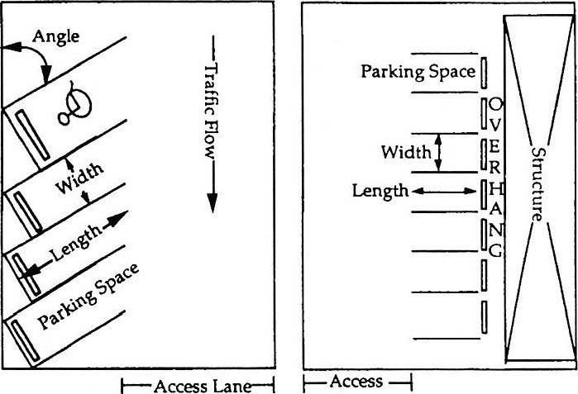

*

*

—l

ACCESSORY USE OR STRUCTURE — Use or building on the same property that is customarily found in connection with, or incidental to, the principal use or building.

ALLEY — A public or private street primarily designed to serve as secondary access to the side or rear of those properties whose principal frontage is on some other street.

ALTERATION — Any change, addition or modification in construction or occupancy of an existing structure.

AMENDMENT — A change in this chapter, including addition of new requirements, revision of existing requirements or deletion of obsolete requirements, necessitating public hearings and other official approvals before becoming effective.

APARTMENT— A room, or suite of rooms, intended, designed or used as a residence by a single family, in auilding with its own cooking, food storage, bathing and toilet facilities and with access directly or via a common hall to the outside.

APPEAL— A plea to a higher agency or court on the part of a person who contends he/she had been aggrieved as the result of a decision of a lower board, commission or individual charged with making the decision he/she is contending.

APPLICANT — A landowner, developer or tenant with notarized permission of the landowner, as hereinafter defined, who has filed an application for development, including his/her heirs, successors and assigns.

APPLICATION FOR DEVELOPMENT -- Every application, whether preliminary, tentative or final, required to be filed and approved prior to the start of construction or development, including but not limited to  an application for a building permit, approval of a subdivision plat or plan or approval of a development plan.

APPOINTING AUTHORITY — The Borough Council of the Borough of South Greensburg.

AUTHORITY— A body politic and corporate created pursuant to the Act of May 2, 1945 (P.L. 382, No. 164), known as the "Municipality Authorities Act of 1945."

AUTOMOBILE LAUNDRY or CAR WASHING FACILITY — A structure used for the purposes of cleaning or reconditioning the exterior and interior surfaces of automotive vehicles, but not including an incidental one-way washing facility in a gasoline service station where washing facilities are purely incidental to the operation of said service station. A self-operating vehicular laundering facility not requiring attendants or employees, regardless of capacity, is also considered to be an "automobile laundry."

AUTOMOBILE SERVICE STATION— Any premises where gasoline and other petroleum products are sold and/or light maintenance activities such as engine tuneups, lubrication, minor repairs and carburetor cleaning are conducted. "Service stations" shall not include premises where heavy automobile maintenance activities such as engine overhauls, automobile painting and body fender work are conducted.

AUTOMOTIVE SALES— The sale or rental of new or used motor vehicles or trailers.

BASEMENT — The space enclosed by the foundation or ground floor walls of a building with a minimum depth of six (6) feet. A "basement" shall not be counted as a story for purposes of height measurement unless one-half (1/2) or more of its height is above average grade.

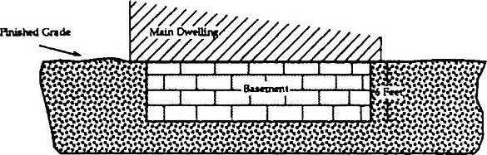

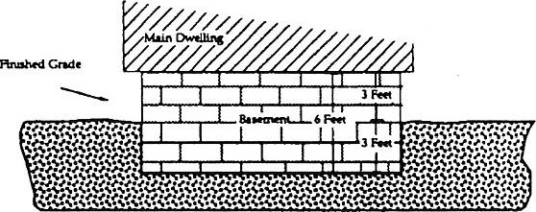

BED-AND-BREAKFAST — An owner-occupied dwelling, or portion thereof, where short-term lodging rooms and meals are provided.

BILLBOARD — See "sign (billboard)."

BOARD — See "Zoning Hearing Board."

BOARDER — An individual, or individuals, other than a family member of the family occupying the dwelling unit, or part thereof, who, for a consideration, is furnished sleeping accommodations and may be furnished meals or other services as part of the consideration.

BOOKSTORE — An establishment having any income derived from the sale of books, magazines and other periodicals.

BOROUGH — The Borough of South Greensburg.

BOROUGH COUNCIL — See "Council."

BOUNDARY— A line, usually a property or street right-of-way line or the center line of a recognizable physical feature such as a highway, stream or railroad, that demarcates the edge of a district or area.

BUFFER— A 'buffer," "buffer area," "buffer yard" or "buffer setback," is a portion of a developed property which must be reserved for landscaping purposes. A "buffer" cannot be used for any purpose other than fencing and landscaping.

Property Line Property Line

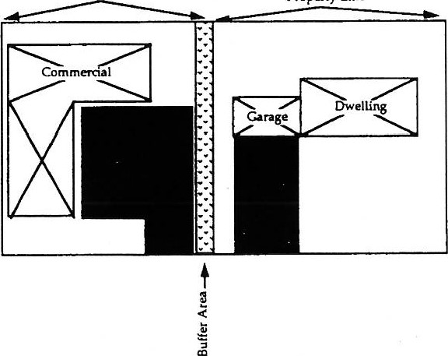

BUILDABLE ACREAGE — A gross acreage reduced by all or a portion of land with sensitive environmental attributes.

Property Line

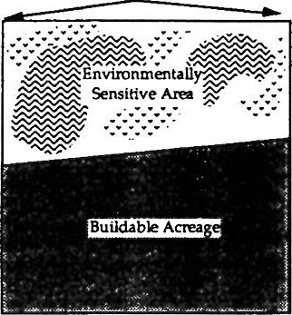

BUILDING — Any man-made object having an ascertainable stationary location on or in land or water, whether or not affixed to the land which is roofed, shall be considered an enclosed building if all exterior walls are solid except for fixed, closed or operable windows and doors.

BUILDING HEIGHT — See "height."

BUILDING PERMIT — Documentation attesting that a proposal for construction meets all requirements of this chapter and other applicable requirements of the Borough of South Greensburg, Westmoreland County and the Commonwealth of Pennsylvania relative to development and allowing such proposed construction to commence.

BULK — The volume of a structure indicating the total space enclosed by the exterior walls and roof.

BUSINESS SERVICES— Any activity conducted for gain which renders services primarily to other commercial or industrial enterprises, or which services and repairs appliances and machines used in homes and businesses.

CAR WASHING FACILITY— See "automobile laundry or car washing facility.'

CARE CENTER, CHILD DAY— A building or structure where care, protection and supervision are provided on a regular schedule, at least twice a week, to twelve (12) or more children, with three (3) or more adult workers in attendance.

CARE HOME, FAMILY DAY— A building or structure where care, protection and supervision are provided on a regular schedule, at least twice a week, to up to six (6) children, including the children of the adult provider, and with one (1) adult worker in attendance.

CARE HOME, GROUP CHILD— A building or structure where care, protection and supervision are provided on a regular schedule, at least twice a week, to from seven (7) to eleven (11) children, including the children of the adult provider, and with at least two (2) adult workers in attendance.

CARETAKER HOME— An accessory structure used expressly for the provision of living quarters and addressing all required yard and bulk requirements.

CELLAR — See ''basement."

CENTER LINE — An imaginary line running parallel to street or easement right-of-way lines and equidistant from the lines on each side of the street or easement, or a line following the center of a physical feature such as a stream or roadway.



CHARITABLE — As applied to any entity, organization, group, business use, operation or function, shall mean and connote that the use, business, operation or function is conducted not for profit, regardless of the nature or purpose thereof, and shall include those entities which have been designated as "charitable" entities under the provisions of the Pennsylvania Solicitation of Charitable Funds Act,the Act of August 9, 1963, P.L. 628, or under any of the provisions of the United States Internal Revenue Code, or of any laws, regulations or rules enacted thereunder.

CHILD DAY-CARE CENTER— See "care center, child day."

CLEAR SIGHT TRIANGLE— A triangular area of unobstructed vision on corner lots formed by a one-hundred-foot sight line along the center line of a local street, and by a line joining these two (2) sight lines at the greatest distance from their intersections.

Primary or Secondary Road

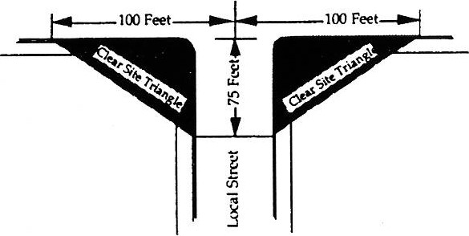

CLUB, PRIVATE:

* 1. An establishment operated by an organization for fraternal, sororial, social, recreational or educational purposes, but open only to members and not the general public.
  2. A nonprofit association of persons who are bona fide members paying periodic dues, and which association owns, hires or leases a building or lot or a portion of either or both, the use of which is restricted to either or both, and the use of which is restricted to members and their guests.
  3. A group of people organized for a common purpose to pursue common goals, interests or activities and usually characterized by certain membership qualifications, payment of fees and dues, regular meetings and a constitution and bylaws.

COMMERCIAL— Engaging in a business, enterprise, activity or other undertaking for a profit.

COMMISSION — See "Planning Commission."

COMMON OPEN SPACE — A parcel or parcels of land or an area of water, or a combination of land and water, within a development site which is designed and intended for the use or enjoyment of residents of a development, not including streets, off-street parking areas and areas set aside for public facilities.

COMMUNITY CLUB — See "club, private."

CONDITIONAL USE — A use of a property that may be granted by Borough Council after receiving recommendations of the Planning Commission based on the express standards and criteria set forth in this chapter.

CONVERSION APARTMENT— A dwelling unit, established from a portion of a larger unit, containing all the facilities normally found in a dwelling unit, including adequate heat, light, plumbing, ventilation and means of access.

CORNER LOT — A lot abutting two (2) or more streets at their intersection and on which the building line for all streets must be observed.

COUNCIL — The Borough Council of South Greensburg, Westmoreland County, Pennsylvania.

COVERAGE — The maximum area or percentage of a lot which may be occupied by structures.

DECISION — Final adjudication of the Zoning Hearing Board and Borough Council. All decisions shall be appealable to the Court of Common Pleas of the county and judicial district wherein the municipality lies.

DECK— An open area usually attached to, or part of, and with direct access to, a building, where said open area is elevated above ground level and is not covered by a permanent roof.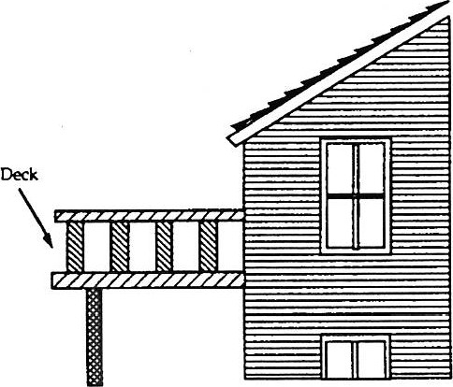

DEPARTMENT— The Pennsylvania Department of Transportation.

DEPENDENT CHILD — Any individual under eighteen (18) years of age in need of supervision and/or special services.

DERELICT VEHICLE — Any vehicle lacking a current license and inspection sticker that is stored out of doors.

DETERMINATION — Final action by the Zoning Officer, except for the following: the governing body; the Zoning Hearing Board; or the planning agency, only if, and to the extent that, the planning agency is charged with final decision on preliminary or final plans under the subdivision and land development ordinance or planned residential development provisions. Determinations shall be appealable only to the boards designated as having jurisdiction for such appeal.

DEVELOPER — Any landowner, agent of such landowner or tenant with written, notarized permission of such landowner, who makes or causes to be made a subdivision of land or a land development.

DEVELOPMENT — The division of a parcel of land into two (2) or more parcels; the construction, reconstruction, conversion, structural alteration, relocation or enlargement of any structure; any mining, excavation, landfill or land disturbance; and any use, or extension of the use, of land.

DEVELOPMENT PLAN — The provisions for development, including a planned residential development, a plat of subdivision, all covenants relating to use, location and bulk of buildings and other structures, intensity of use or density of development, streets, ways and parking facilities, common open space and public facilities. The phrase "provisions of the development plan," when used in this chapter, shall mean the written and graphic materials referred to in this definition.

DOMESTIC ANIMALS — Animals that are customarily kept for personal use or enjoyment within the home. Household pets shall include but not be limited to domestic dogs, domestic cats, domestic tropical birds and rodents.

DRIVE-IN COMMERCIAL USES — Any retail commercial use providing considerable off-street parking and catering primarily to vehicular trade, such as drive-in restaurants, drive-in theaters and similar uses.

DRIVEWAY — A privately owned and maintained vehicular accessway within a property.

DWELLING — A building, or structure, or manufactured home, designed or used exclusively for residential occupancy, including single-family dwellings, duplexes and multifamily dwellings, but not including hotels or lodging and boarding homes.

DWELLING DENSITY— The maximum number of dwelling units permitted per acre or per lot.

DWELLING, MULTIFAMILY — A building, which is the only principal building on the lot, containing three (3) or more dwelling units.

DWELLING, SINGLE-FAMILY — A residential building containing not more than one (1) dwelling unit.

DWELLING, SINGLE-FAMILY, ATTACHED (ROW AND TOWNHOUSES)— One (1) of two (2) or more dwelling units separated by a common party wall and which have ground floor access to the outside.

DWELLING, SINGLE-FAMILY, DETACHED— A residential building containing not more than one (1) dwelling unit entirely surrounded by open space on the same lot.

DWELLING, TWO-FAMILY — A structure designed for two (2) dwelling units, whether side-by-side or one above the other, with each unit having means or egress directly to the outside, at grade or via an exterior stairs to grade.

DWELLING UNIT— A group of connected rooms, whether in a separate structure, a duplex, townhouse or apartment building, including, in each unit, bathing, toilet and cooking and food storage facilities for the exclusive use of one (1) family or not more than three (3) unrelated individuals.

EFFECTIVE DATE — The date on which this chapter is duly adopted by the borough or as specified in an ordinance adopting the same.

ENTERTAINMENT FACILITIES — Any activity conducted for gain which is generally related to the entertainment field, such as motion-picture theaters, bowling alleys, roller-skating rinks, miniature golf, golf driving ranges, commercial swimming pools, carnivals and related uses.

FAMILY - A group of not more than three (3) persons who need not be related by blood or marriage or adoption, living together as a single housekeeping unit in a dwelling unit and sharing common facilities as considered reasonably appropriate for a family related by blood, marriage or adoption. This definition excludes occupants of a club or a dormitory, fraternity, sorority house, lodge or rooming house, group quarters and a student home. **[Amended 6-8-2009 by Ord. No. 2009-04.]**

FAMILY DAY-CARE HOME— See "care home, family day."

FENCE — A barrier constructed of materials other than trees and erected for the purpose of protection, confinement, enclosure or privacy.

FLOOR AREA — The sum of the gross area of all floors of a building measured from the face of interior walls.

FLOOR AREA, GROSS (GPA) — When prescribed as the basis of measurement for off-street parking space and loading berths for any use, "floor area" shall mean the sum of the gross areas of the floors of buildings, or portions thereof, devoted to such use, including accessory storage areas located within selling or working space, such as counters, racks or closets; and any basement floor area devoted to retailing activities, to the production or processing of goods or to business or professional offices.

FOOD PROCESSING/SALES— The retail sales of foodstuffs and associated merchandise packaged for consumption, after preparation, off the premises where sold and not including any restaurant or take-out establishment.

FRONT YARD — The area of any property between the front lot line and front setback line (see "setback" diagram).

FRONT YARD LINE — A front yard line bounds the front yard and is parallel to the front line (see "setback" diagram).

GOVERNING BODY— The Borough Council of the Borough of South Greensburg.

GRADE — The average elevation of the finished ground adjoining the building on all sides as referenced to the center line grade of streets abutting the lot.

GRADING — The process of changing the natural surface of the land in order to carry out a development plan.

GROSS ACREAGE — The total acreage of a tract for which an application is filed or approved.

GROUP CHILD-CARE HOME — See "care home, group child."

GROUP HOME FOR THE HANDICAPPED— A dwelling shared by three (3) or more handicapped persons, including resident staff, who live together as a single housekeeping unit and in a long-term, family-like environment in which staff persons provide care, education and participation in community activities for the residents with the primary goal of enabling the resident to live as independently as possible in order to reach their maximum potential. As used herein, the term "handicapped" shall mean having: a physical or mental impairment that substantially limits one (1) or more of such person's major life activities so that such person is incapable of living independently; a record of having such an impairment; or being regarded as having such an impairment. However, "handicapped" shall not include current illegal use of or addiction to a controlled substance, nor shall it include any person whose residency in the home would constitute a direct threat to the health and safety of other individuals. The term "group home for the handicapped" shall not include alcoholism or drug treatment centers, work release facilities for convicts or ex-convicts or other housing facilities serving as an alternative to incarceration.

HEIGHT — The vertical distance along the wall of a building measured between the average of the highest and lowest elevation at ground level on the front or rear facade, whichever has the lower ground elevations, and the top of the parapet on a flat roof building or halfway between the eaves and highest ridge line on a sloped roof building, except that chimneys, stacks, steeples, roof-mounted air-handling equipment and similar projections of the building, not intended for human occupancy, shall not be considered in measuring height.



HEIGHT OF BUILDING -- See "height."

HEIGHT OF SIGN -- The vertical distance measured from ground level to the highest point on the sign, or its supporting structure.

HIGHWAY ACCESS POINT -- The intersection of an accessway or driveway from a lot or parcel of ground with a public street or right-of-way.

HOME OCCUPATION, MAJOR -- A home occupation in which no persons, other than members of the family residing on the premises, and one (1) nonresident, are engaged in the occupation, which has not more than one (1) unilluminated sign as visible evidence of conduct of the occupation and which accommodates both dwelling and home occupation parking needs off the street. (Some examples of these occupations include catering services or barber/beauty shops.)

HOME OCCUPATION, MINOR -- A home occupation in which no persons, other than members of the family residing on the premises, are engaged in the occupation, which has no visible exterior evidence of the conduct of the occupation, which does not create a need for off-street parking beyond normal dwelling needs, which does not generate additional traffic and in which no equipment is used other than that normally used in household, domestic or general office use. (Examples of "minor home occupations" include telemarketers or telephone solicitors.)

JUNKYARD -- Any portion of any lot, whether inside or outside a building, for storage, keeping or abandonment of automobiles or other vehicles, machinery or parts thereof and any worn, castoff or discarded article or material which is ready for destruction, or which had been collected or stored for sale, resale, salvage or conversion to some other use.

KENNEL, COMMERCIAL -- The boarding, training, grooming or showing of more than four (4) domestic animals shall be limited to dogs, cats and such other species as may be considered pets in a residential setting.

LAND DEVELOPMENT -- Any of the following activities:

(1) The improvement of one (1) lot or two (2) or more contiguous lots, tracts or parcels of land for any purpose involving:

(a) A group of two (2) or more residential or nonresidential buildings, whether proposed initially or cumulatively, or a single nonresidential building on a lot or lots, regardless of the number of occupants or tenure; or

(b) The division or allocation of land or space, whether initially or cumulatively, between or among two (2) or more existing or prospective occupants by means of, or for the purpose of streets, common areas, leaseholds, condominiums, building groups or other features.

(2) A subdivision of land.

(3) Development in accordance with the Pennsylvania Municipalities Planning Code (Act 247, as amended by Act 170 of 1988).

LEGISLATIVE BODY -- Borough Counsel of the Borough of South Greensburg.

LIVE ENTERTAINMENT - Defined as follows, and shall not include any lewd, indecent and/or immoral entertainment:

1. Music or vocals provided by one or more professional or amateur musicians or vocalists;

2. Acting or drama provided by one or more professional or amateur actors or players;

3. Comedy or magic performed by one or more professional or amateur comedians, magicians, illusionists, entertainers or performers;

4. Dancing performed by one or more professional or amateur dancers or performers;

5. Athletic or sporting contests, events or exhibitions provided by one or more professional or amateur athletes or sportsmen;

6. Animal stunts or performances induced by one or more animal handlers or trainers;

7. Acrobatics or stunts provided by one or more professional or amateur acrobats, performers or stunt persons;

8. A show or productions involving any combination of the activities described in subparagraphs 1-7, inclusive; and

9. A performance involving one or more of the activities described above by a disc jockey who presents recorded music. For purposes of this subsection, a disc jockey shall not be deemed to have engaged in a performance involving one or more of the activities described above if the disc jockey generally limits his or her interaction with patrons to introducing the recorded music, making announcements of general interest to patrons and explaining, encouraging or directing participatory activities between and among patrons. **[Added 5-13-2013 by Ord. No. 2013-03.]**

LOADING AREA -- An area of property on which activities are of such a nature as to require continuous receiving and/or shipping of goods, such area to be used exclusively for loading and not to interfere with other vehicular or pedestrian circulation on the property.

LOT -- A designated lot of record, tract or area of land established by a plat or otherwise as permitted by law and to be used, developed or built upon as a unit.

LOT, CORNER -- A lot abutting on and at the intersection of two (2) or more streets.

LOT COVERAGE -- The maximum area which may be occupied by structures.

LOT, FLAG -- A lot with access provided to the bulk of the lot by means of a narrow corridor.

LOT, INTERIOR— A lot other than a corner lot or flag lot.

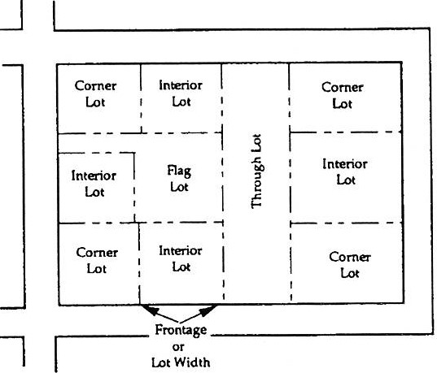

LOT LINE, FRONT — That boundary of a lot which is along an existing or dedicated street or right-of-way, with corner lots having two (2) "front lot lines."

LOT LINE, REAR — The line generally parallel to the front lot line, which defines the rear of the lot. A lot bounded by only three (3) lot lines will not have a "rear lot line."

LOT LINE, SIDE — Any lot line which is not a front lot line or a rear lot line.

LOT OF RECORD — A lot which has been duly recorded in the office of the Recorder of Deeds of Westmoreland County, either individually or as part of a subdivision.

LOT WIDTH — The horizontal distance between side lot lines measured along the front lot line, unless otherwise specified, or, in exceptional cases, the average lot width for the entire depth of the property